Assignment – III  
  
 Name: K MS VEERENDRA NATH

Reg No: 20BDS0203  
 Campus: Vellore  
 E – Mail: [veerendranath.kms2020@vitstudent.ac.in](mailto:veerendranath.kms2020@vitstudent.ac.in)  
  
1) Create the following with whatever visualizations you have built in assignment-1 & 2(if you want you can also create new visualizations)

* Dashboard
* This is the symbol we need to click to create dashboards.

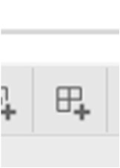  
  
🡪 There we can find all the worksheets of we have prepared earlier from there we can choose.  
  
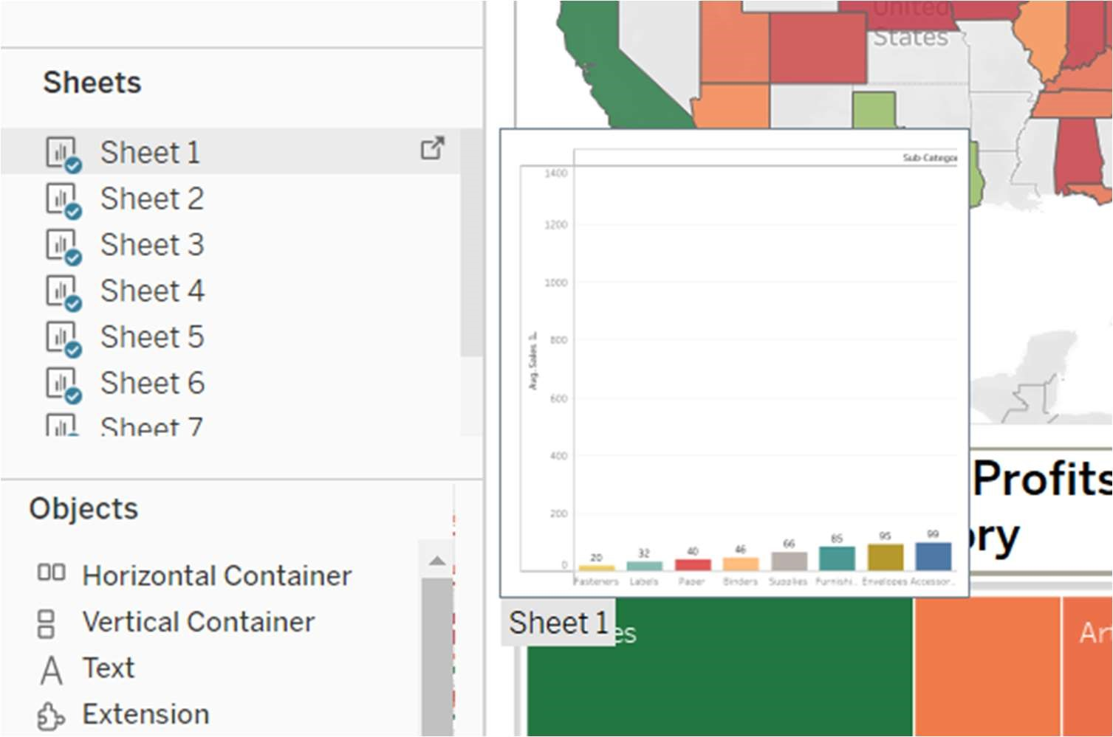  
  
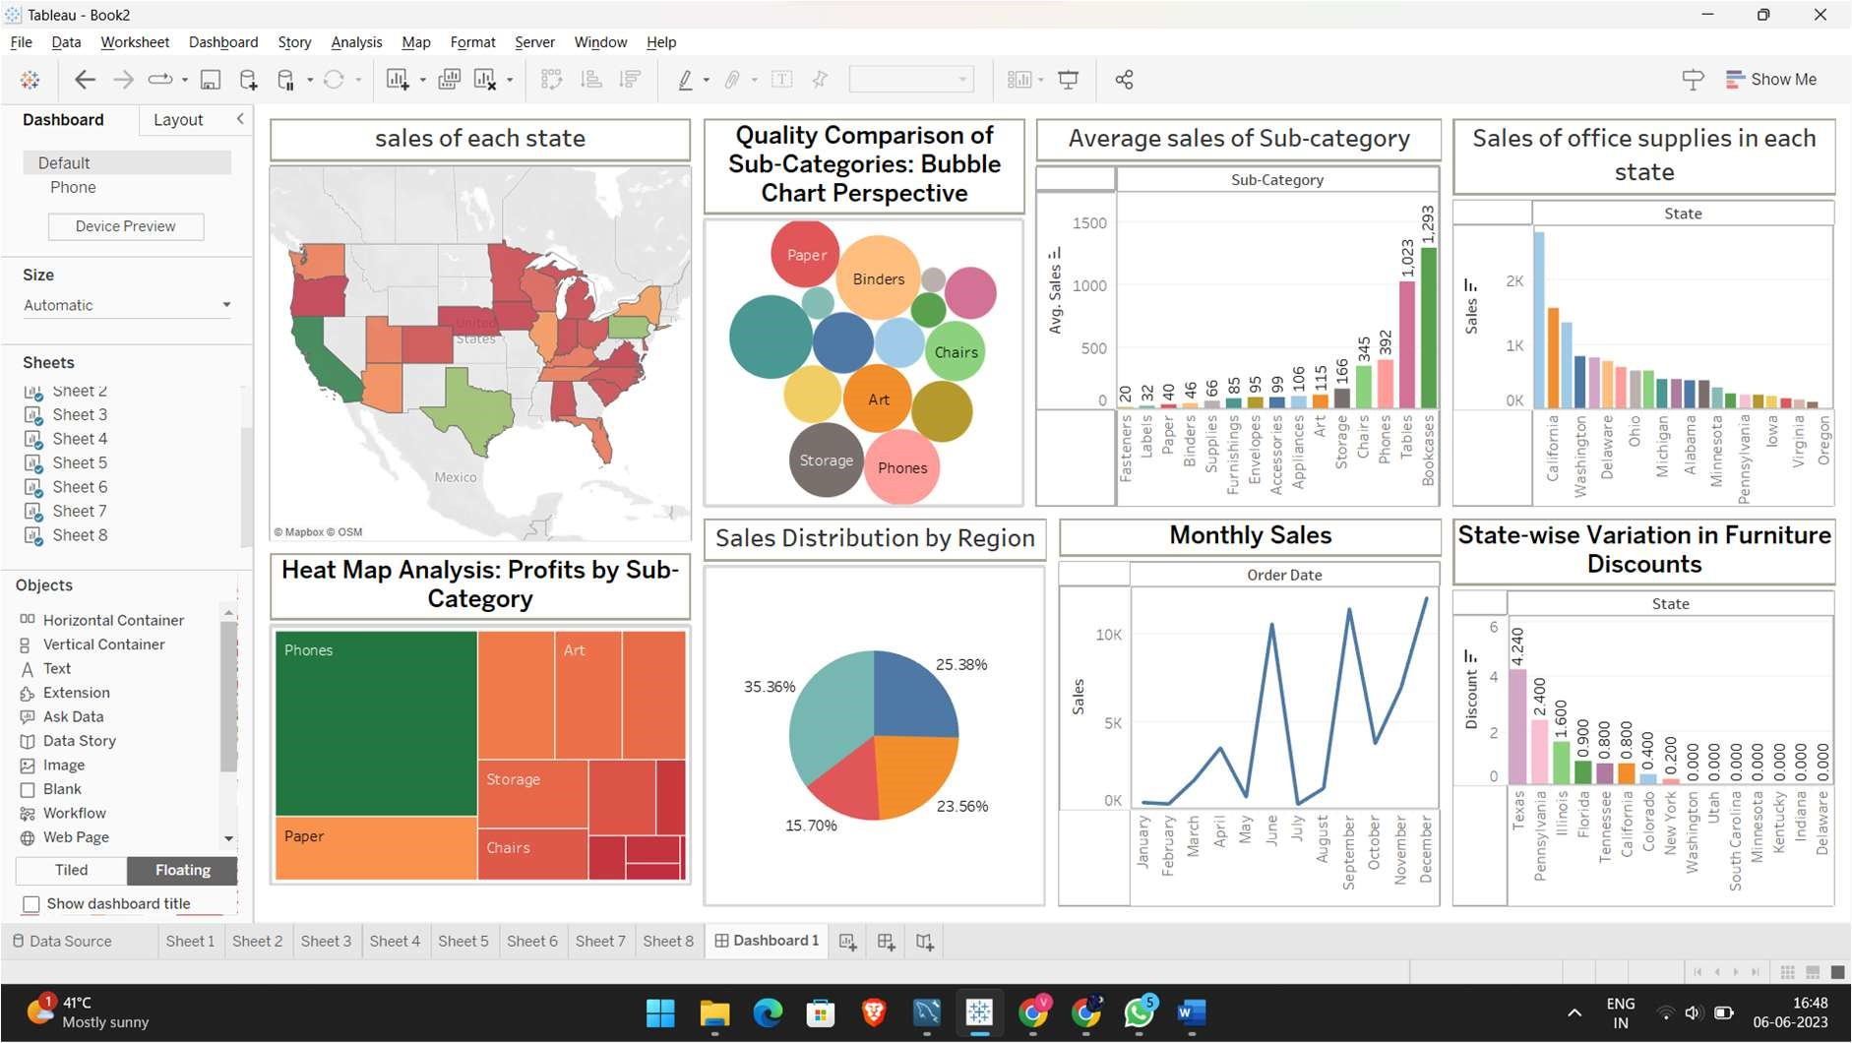  
  
● Story

This is the symbol we need to click to create a story.  
  
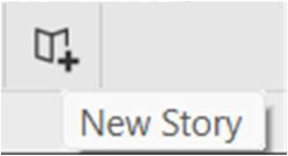  
  
  
🡪 In this area we can find all the worksheets to add in story.  
  
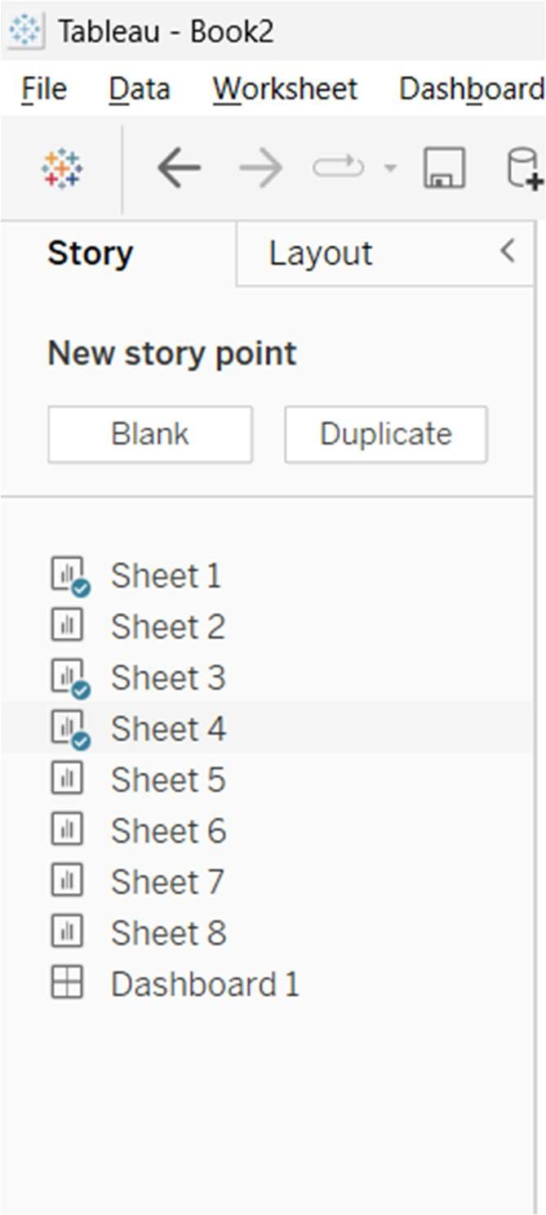  
  
🡪 Here we can write the descrip on of worksheets in a story.  
  
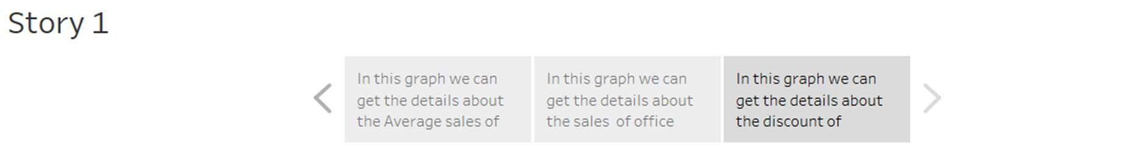  
  
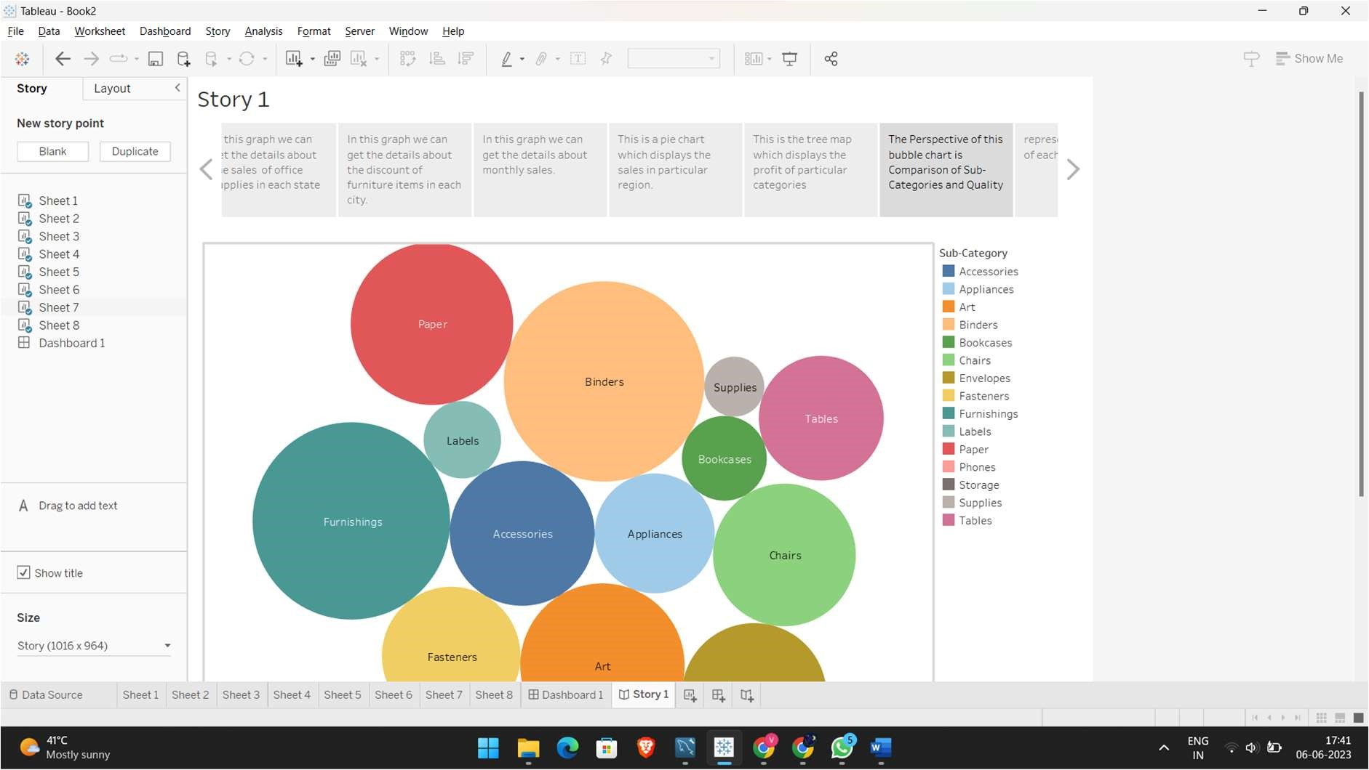  
  
  
2) Publish the dashboard & story on to tableau public server

* To publish the dashboard & story on to tableau public server we need to click the share symbol on the top right,

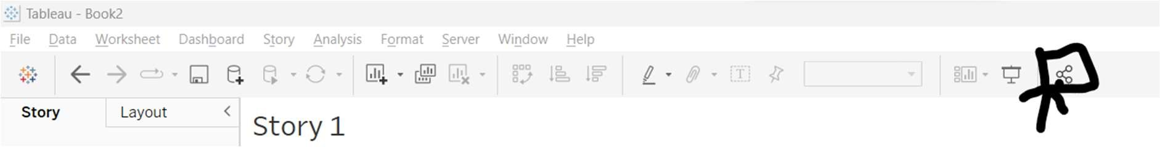  
  
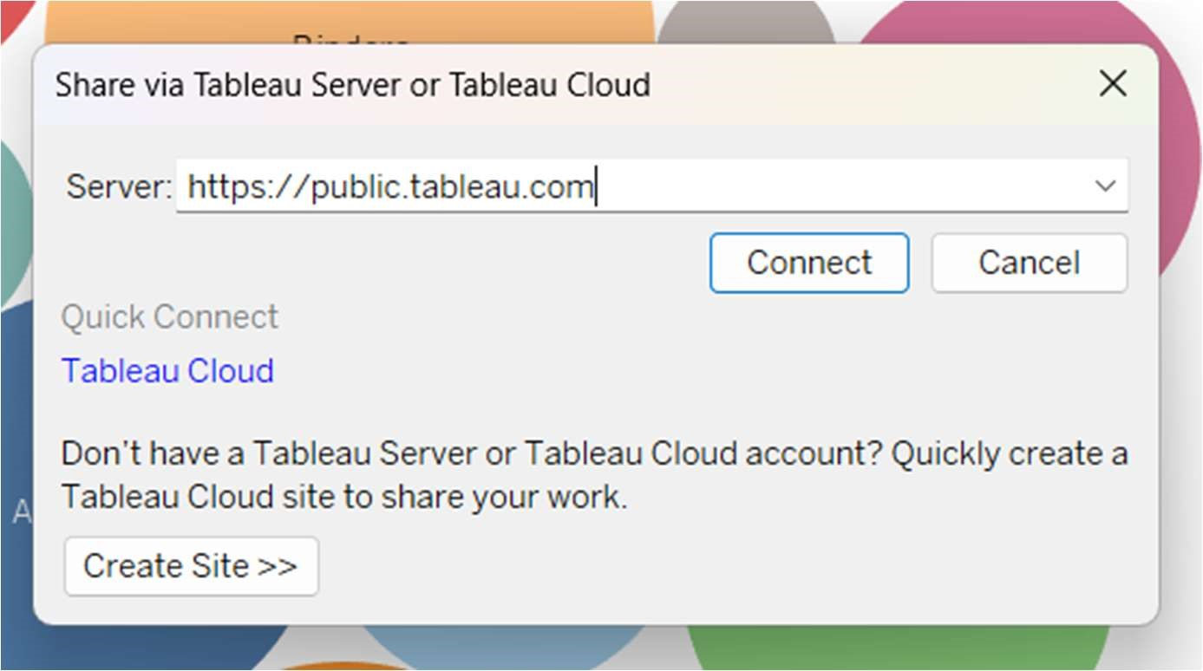  
  
🡪 Now click on connect.

* After that we can get it in tableau public.

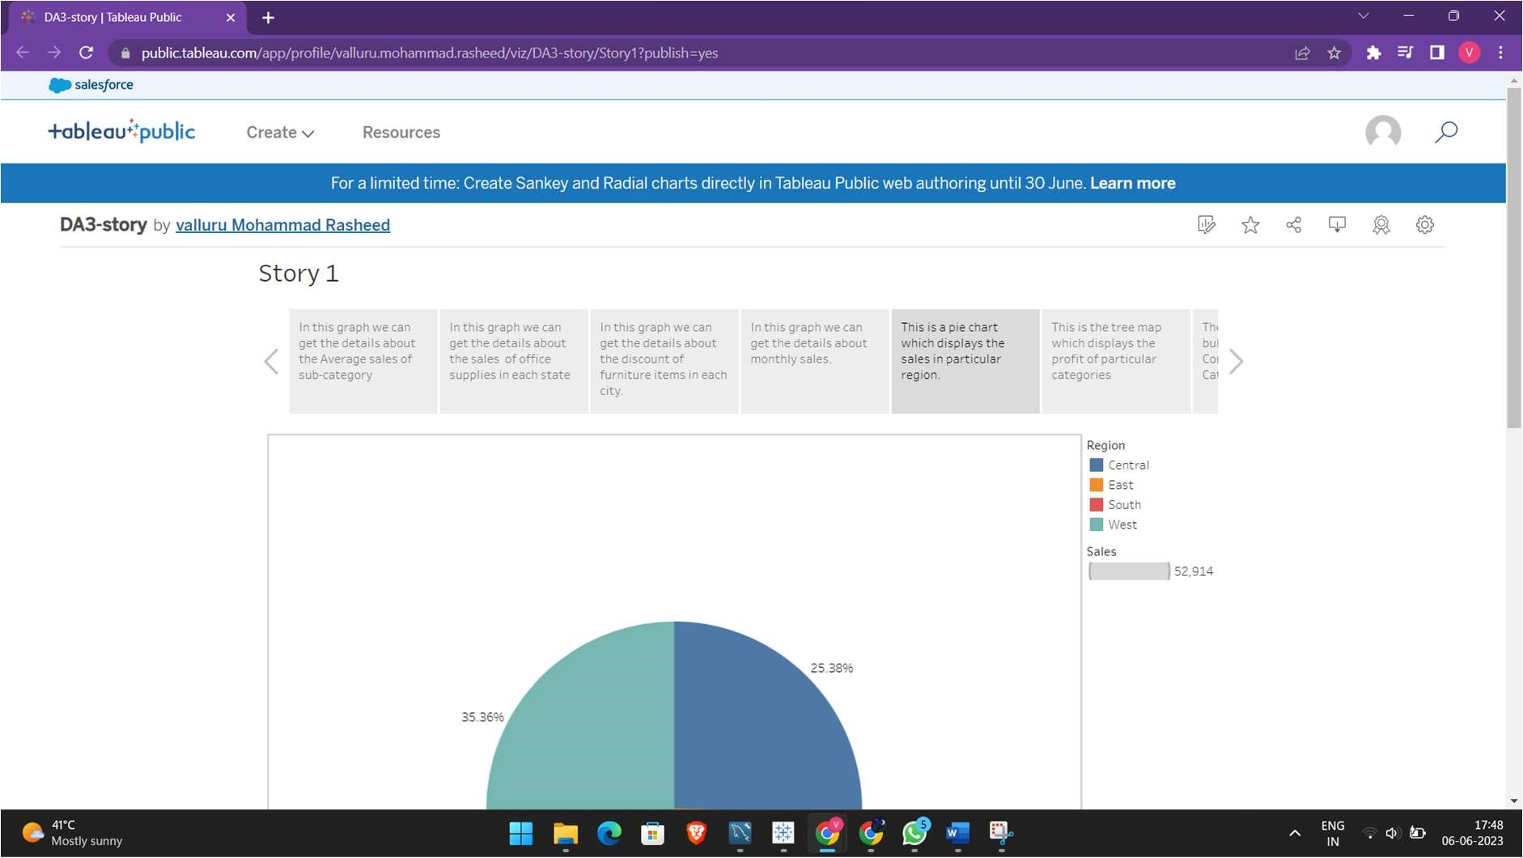  
  
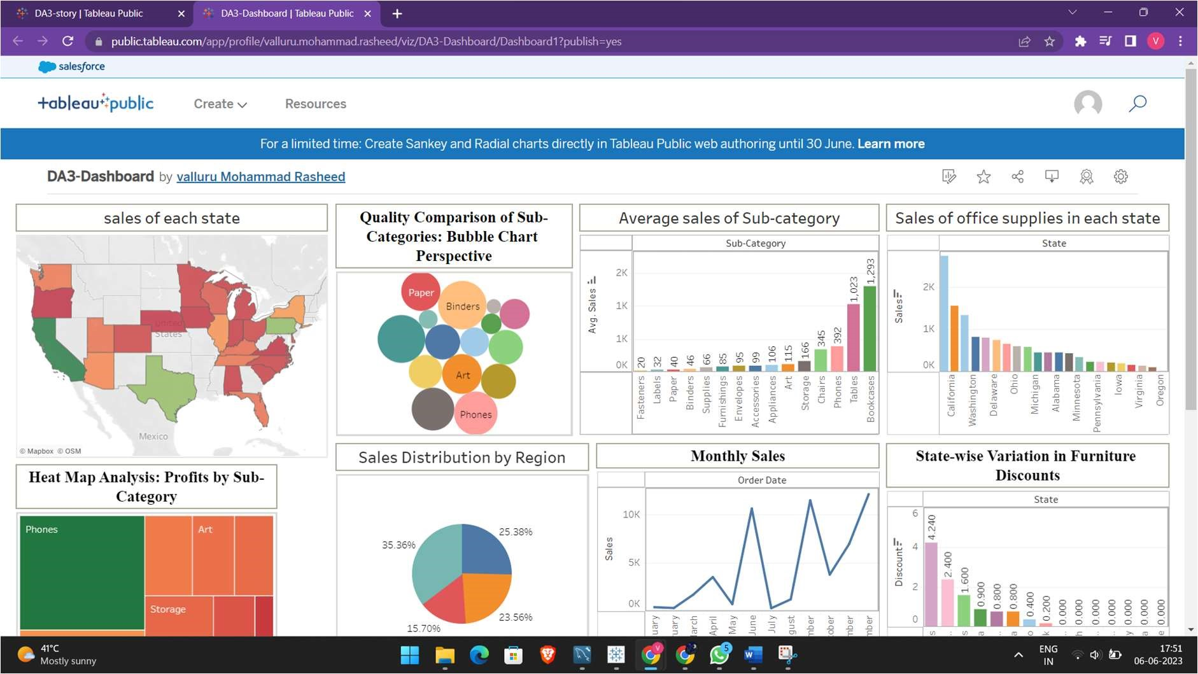  
  
Story link:   
https://public.tableau.com/views/DA3-story/Story1?:language=enGB&publish=yes&:display_count=n&:origin=viz_share_link

Dashboard link: -   
https://public.tableau.com/views/DA3-Dashboard/Dashboard1?:language=enGB&publish=yes&:display_count=n&:origin=viz_share_link

*---------------------------------*